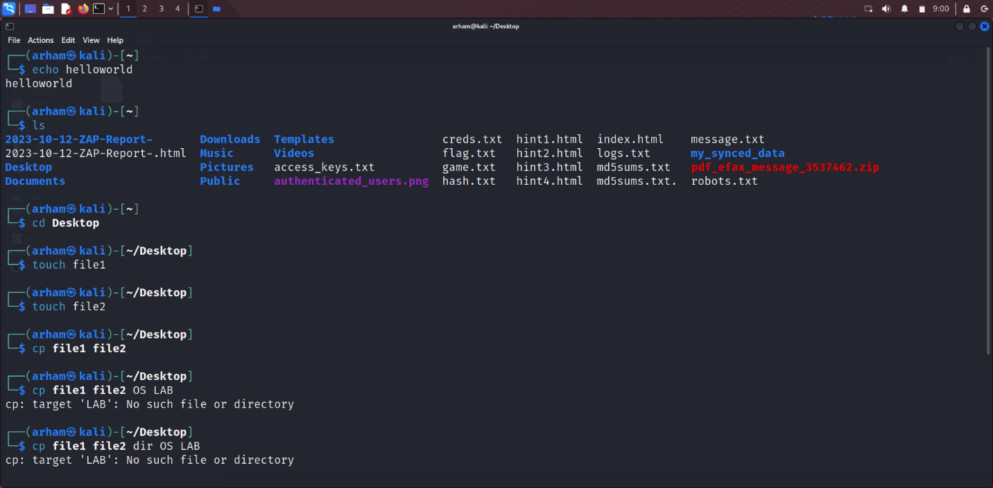

Used echo to print hello world.

Ls to see the files in the directory.

Cd to go in a directory.

Touch to create file.

Cp to copy contents of file1 to file2.

Head and last prints file contents in ascending and descending order.

Sort’s the file contents

Grep finds a particular letter or word in the file.

The above are related to bash scripting, in which we wrote our commands in the file, and then when we run the file, the commands execute one by one, saves us time when we need a particular sequence of commands to execute at once.